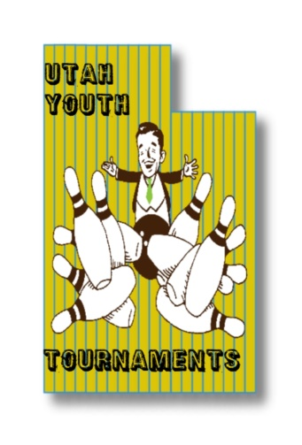
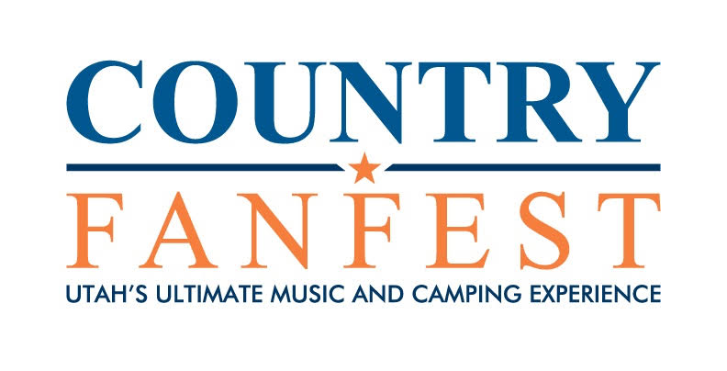
Youth Flat Challenge

February 12th, 2023
8:30-8:50AM Registration 9:00AM Start
$25
Delton Lanes
3544 W. 3500 S., West Valley City, UT

$150 Guaranteed to each division winner!

register online at Tournamentbowl.com
www.utahyouthbowling.com
Tournament Director: Steven Vanderbloom (Cell) 435-841-7862
E-mail: utahyouthtournaments@gmail.com

Name____________________________________________ Sex_______ USBC #___________________________
Address______________________________ City_________________________ ST_____ Zip_____________
Date of Birth___________________ Junior Gold YES NO
Phone_________________ E-Mail_________________________________________

Youth Flat Challenge (07541)
ELIGIBILITY: Open to all USBC Youth members with a valid membership in good standing
DIVISIONS and FORMAT: This is a handicap tournament. All bowlers will bowl 3 games. The divisions will be based on 2021-2022 USBC composite average. Division A will be 0-149 average and Division B will be 150-300 average.
If there is no average for the previous season, the bowler will use their current average of at least 9 games. Any bowler who does not have an average will bowl scratch and will be entered in to division B.
Handicap will be 85% of 250
ENTRY FEES: Fee per Person - $25.00 Breakdown – Scholarship/prize fund $13.00, Lineage $10.50, Expense $1.50. 100% of prize/scholarship fund will be awarded. No Refunds – USBC Rule 314. Junior Gold entry fee is U18 $45, U15 $35, U12 $25.
BOWLER’S AREA: Only participants & tournament officials are permitted in the bowling area.
DRESS CODE: All participants may wear casual slacks, trousers, jeans, skorts and shorts. All participants are required to wear a shirt with sleeves. Collared or Mock Collared shirts are preferred. Unacceptable attire includes, but not limited to: Tank tops, bare midriffs, workout attire, lounge pants, bib overalls, jeans that are torn, hats or attire with inappropriate, or offensive language or graphics. The tournament management will have final decision on all dress code related issues and reserves the right to require any participant to change any article of clothing determined not appropriate for tournament participation. If bowler refuses to change once requested, bowler will be disqualified and forfeit entry fee for the event of occurrence.
SCHOLARSHIPS AWARDS: Scholarship Prize Fund will be paid out to at least the top 4 in each division.
Junior Gold Qualifier – This event will be a Junior Gold Qualifier. Bowlers will use their first 3 games for qualification in their age division. Tournament organizer has the right to combine divisions if needed. U18, U15, and U12 will advance at a 1 to 4 ratio. In case of a tie there will be a 10th frame roll off. If the score is still tied, bowlers will bowl one shot at a time until the tie is broken with the highest pin count advancing.
All rules for the 2021/2022 Youth Flat Challenge are subject to change due to concerns with COVID-19. This includes, but is not limited to, tournament dates, locations, format(s), operations and bowler services.
Any disputes must be brought to the tournament officials on site at the time of occurrence and will be settled at that time. All protests and appeals must be in accordance with USBC Rule 329. Anything not covered within the tournament rules will be governed by tournament management and USBC national playing rules.
Lane oil pattern will be red square.

